**Team Name:** ' ); DROP TABLE Grades; --

**Team Members**: Sophia Chimenti ([chimes@rpi.edu](mailto:chimes@rpi.edu)), Brooke Kinsey ([kinseb2@rpi.edu](mailto:kinseb2@rpi.edu)), Ghea Chaw ([chawg@rpi.edu](mailto:chawg@rpi.edu)), JJ Whitehurst ([whitej20@rpi.edu](mailto:whitej20@rpi.edu)), Felipe Alves ([alvesf@rpi.edu](mailto:alvesf@rpi.edu))

____________________________________________________________________________

**Summary of Proposed Project:**

With our project, RoomEase, we plan to alleviate the stress and difficulty of finding a roommate and later down the road finding off-campus housing. For this project, we will have two main focuses/functions: finding roommates and finding off-campus housing.

Finding roommates, especially as a freshman, can be difficult and scary. As of right now, the RPI housing portal has a survey you can fill out with your personal details (i.e. when you wake up/go to sleep, how messy you are, etc.) and then shows you people who most closely match what you said in hopes of finding someone you will find easy to live with. Although not directly associated with RPI housing, there is an Instagram page that is usually run by upperclassmen where incoming freshmen will DM the account with pictures and personal information about themselves, whether that be hobbies or cleanliness preferences. This is not a very reliable system, since I know multiple people never got posted on the page and therefore had a difficult time finding someone before the housing application deadline. Our project aims to eliminate the middleman and unimportant questions such as music taste, deciding whether you and a potential roommate are compatible for living together. In a similar fashion, our project will give the user a survey, asking questions similar to those of the housing survey, and will also give the user the option to add a more descriptive bio about themselves, much like the Instagram page. It will be the best of both worlds in that you can find a person you are compatible with but also someone who shares the same interests as you.

Finding off-campus housing as a junior or senior is difficult, especially since this is most if not all, people’s first time looking to rent out a place to live. This whole process, much like finding a roommate, can be an extremely daunting task. Our project aims to alleviate some of this stress by putting a bunch of nearby rental listings on our site and providing more of an insight into what the property is like. We also hope to add a feature to show who is interested in a property so the user can view if a property will be taken or available by the time they are ready to commit to renting out a place. With the help of reviews from students and our research, we aim to compile a database of affordable, quality housing near campus for students to rent out. By putting all of these listings in one place with good reviews and pictures for students by students, we hope to ensure a smooth transition from on-campus to off-campus housing for all students at RPI.

The reason for choosing RoomEase as opposed to any other application is that it is designed by RPI students who have been through the roommate-finding process and are getting ready to live off-campus. We also aim to take all the positives, such as a personality quiz, from these preexisting applications and hone it to be more specific and account for the little things that have gone unconsidered in the past. We also hope to use student reviews for the off-campus housing section, so the new live-ins can see real reviews from students at RPI.

**Description of each type of user and stakeholder, and how the site generates value for each:**

Our users would primarily be students finding roommates for on-campus housing or upperclassmen looking for off-campus housing options and roommates. One specific type of student looking for an on-campus housing roommate would be an incoming freshman (though this site would have value for any student in this situation), incoming students lack many of the spaces to meet other RPI students of their year that they believe would be suitable to room with. Though spaces such as class Discord servers exist, they only have a rudimentary system of finding roommates that would be less efficient than our site. With our site, firstly, the pool of potential roommates would not be restricted to only those on the server, but it would also feature a more comprehensive survey about potential interests and where they would like to room. Our site would also feature a system of efficiently finding roommates with a search system containing various filters to expedite the process, making it easy to find people who match the user’s personal requirements for a roommate without having to use platforms such as Instagram or Discord to manually find people and scope out what type of roommate they would be.

Another stakeholder would be upperclassmen looking for roommates for off-campus housing. One glance at the r/rpi subreddit shows various posts from people desperately searching for roommates to sublet their off-campus housing with little to no response, even though dozens of these posts appear daily. With our site, they would be able to advertise the type of housing they have and find roommates looking for something similar. They would also be able to easily reach out to potential roommates and have a, once again, more expedited process of searching for roommates, overall increasing the quality of the roommate-finding process and lowering the stress of having to make various posts across forums desperately looking for someone.

A third user would be someone (possibly not a student) who has come to advertise their own housing that they wish to lease out to students. They would be advertising to students who are looking for housing during the semesters, which is their target audience. This would allow the user to directly access the audience who would benefit the most from the business they offer, which is an enticing opportunity.

**A summary of the technologies you intend to use:**

The foundation of all our pages on the RoomEase website will be built using HTML, allowing us to display information on the website in a standardized way, as HTML is the markup language that all browsers understand. Next, we will use CSS on all pages, so we can make the pages visually appealing, and make sure they follow some sort of layout, such as a consistent navigation bar, footer, font, and other features, making our website as user-friendly as possible. Then, we will use Javascript for the dynamic content on our website such as real-time updates on properties available, search filters for both the property search process and roommate finding process, and processing the roommate matching survey. In addition to Javascript, we will use PHP so we can interact with our MariaDB database to retrieve information saved there such as user profiles, user login, housing information, and housing reviews. PHP will also make sure that only RPI students can create profiles and interact with the roommates section of the website.

**Any functional and non-functional requirements:**

Our functional requirements include:

* The ability to make an account with a visible profile
  + The main function of our site relies on each user having a visible profile tied to their account in order for other users to find them and contact them. The profile for those seeking out roommates will be tied to their RPI email, ensuring that only RPI students can find other RPI students in the area.
* The ability to take a survey to display interests on the user’s profile
  + Our users will seek out potential roommates based on the results of a survey they took when setting up their profile, which provides an in-depth questionnaire into specifics about their living style and how they want their living situation to be.
* A search function that allows the user to filter by various interests
  + The search function provides an efficient way to filter out and specifically search for various interests and traits of potential roommates, eliminating the task of having to scroll through various profiles that do not match the needs and wants of the user.

Our non-functional requirements include:

* Accessibility
  + The site should have an accessible interface, meaning the various features are easy to find and use.
* Usability
  + Similar to accessibility, the site should be easy to use and not have a cluttered or complicated UI.
* Safety
  + The site should provide a safe experience when searching for roommates by ensuring that only those who sign up with an RPI email should be advertised as potential roommates. This ensures that potential roommates are only members of the RPI community.

**An estimated project schedule:**

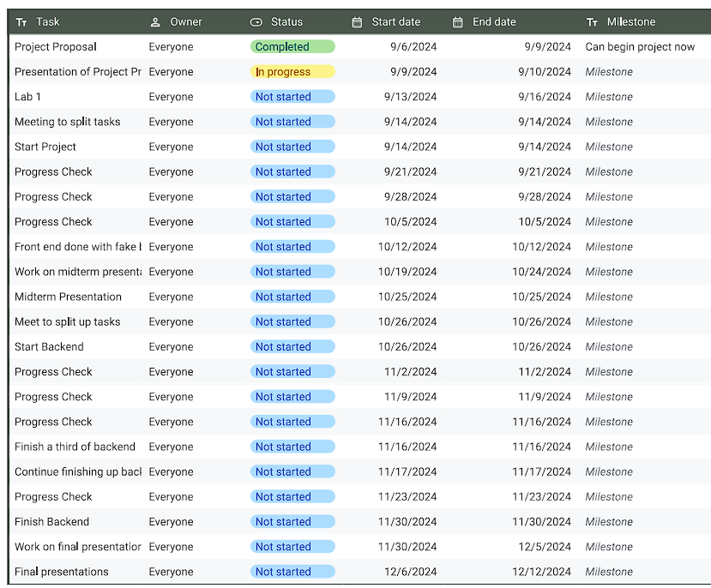

Link to the spreadsheet: [RoomEase](https://docs.google.com/spreadsheets/d/1dhYQgFg7PmLYFoKhvhGLJRxG7CXpfLgF_oo5Zd12kb8/edit?usp=sharing)

**A site map demonstrating the basic structure of your site:**

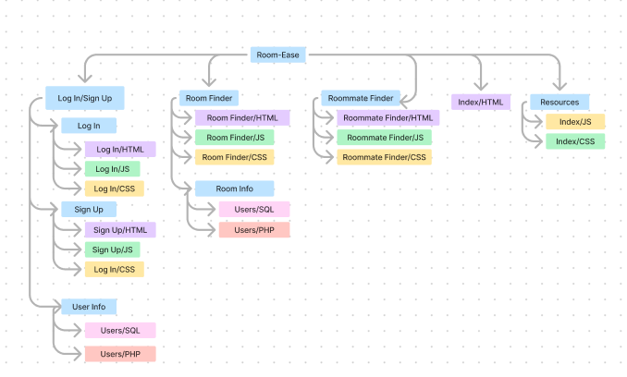

**Two wireframes of pages that help demonstrate the intended functionality:**

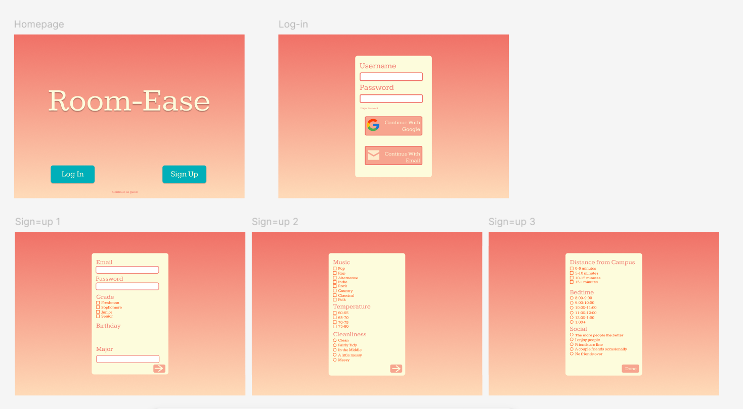

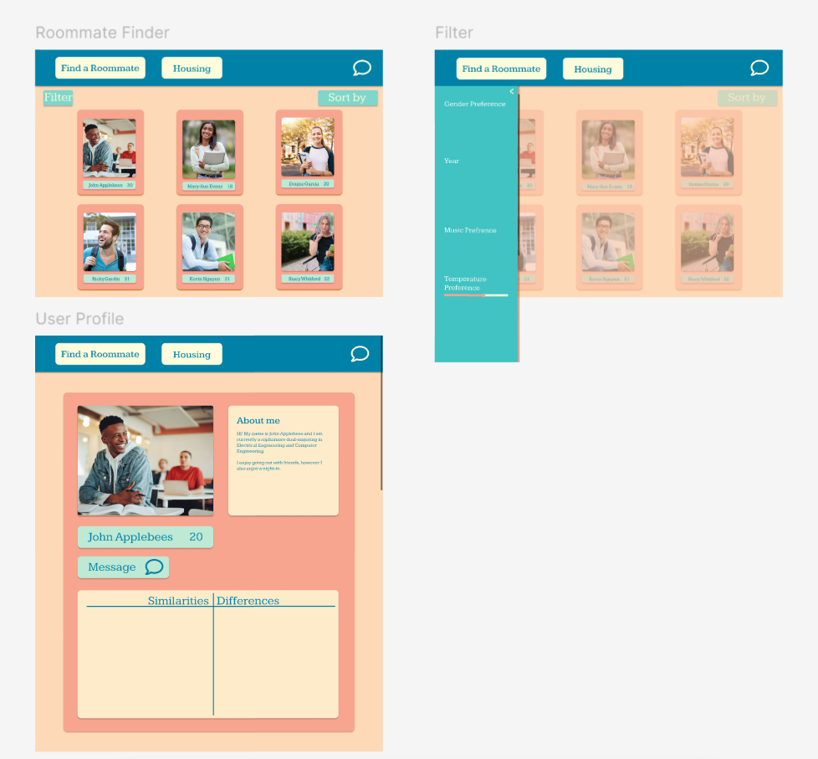

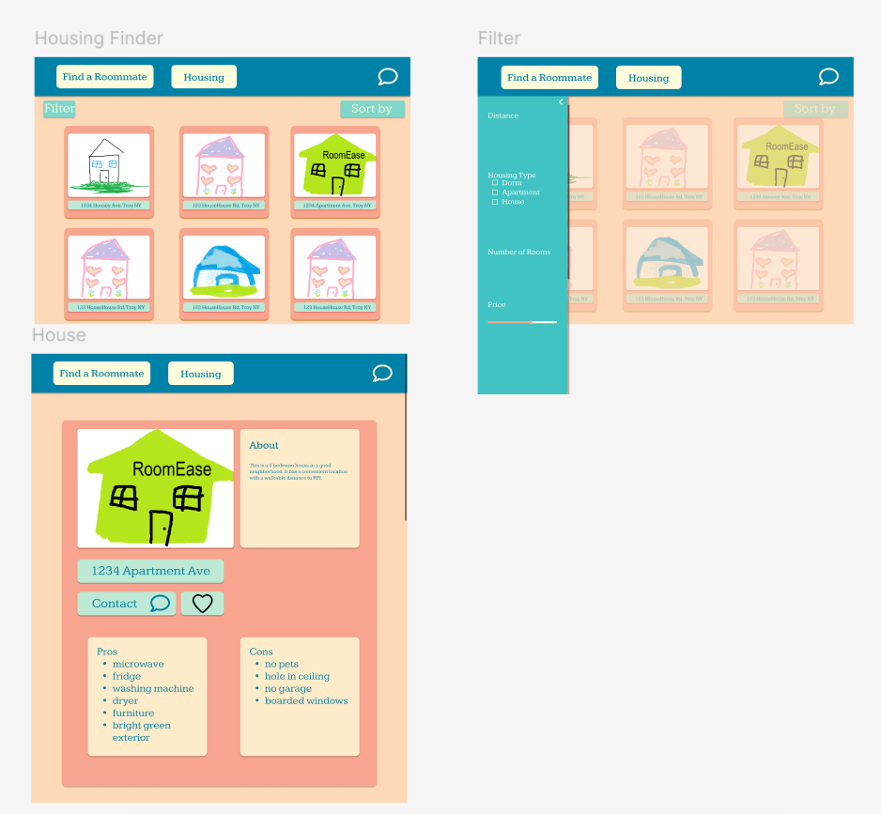

**A 60-second Instagram video advertisement (will be posted on the ITWS Ig):**

Link: <https://youtu.be/g7f5Y8djxEo>